

Cambridgeshire County Council Business Plan and Budget 2026 to 2029: Easy Read Survey Part 2

Pictures | Words
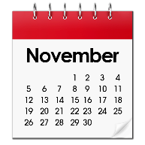  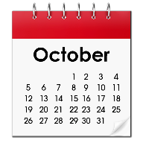 | From 24 October to 24 November 2025, we asked you about council spending and savings.
  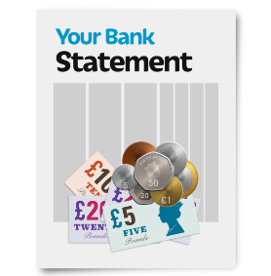 | 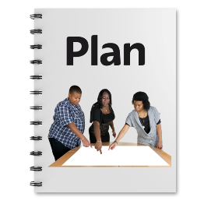  Your answers helped us make our 2026-2029 Business Plan and Budget.
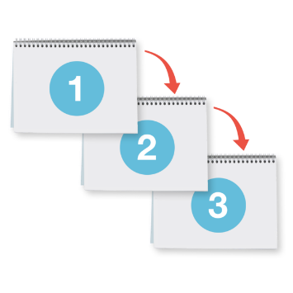 | This survey is the next part of asking for your views.  It has 3 parts.
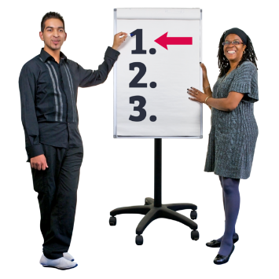 | The first part explains why we are doing this.
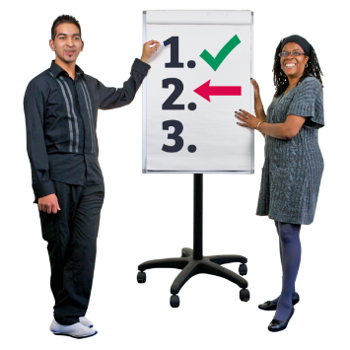 | The second part asks what you think about the council’s spending, saving, and investing.
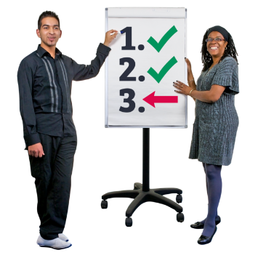 | The third part asks some questions about you.
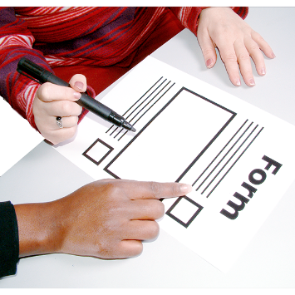 | You can ask somebody to help you read the questions and answer them if you want.  But they should not tell you which answer to pick, because we want to know what you think.
 | You do not have to tell us who you are.  We will keep your answers safe and private.
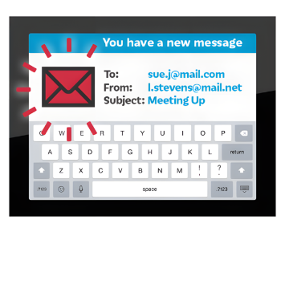 | If you have questions about the survey, you can email:  CCCBusinessPlanning@cambridgeshire.gov.uk
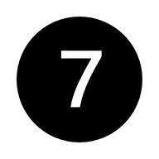   | Please return this survey to us by: 7 January 2026
  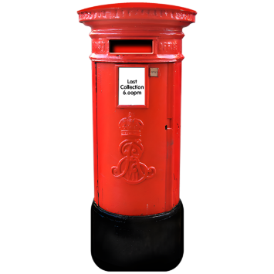 | Please return your survey by email to:  CCCBusinessPlanning@cambridgeshire.gov.uk  Or by post to:  Cambridgeshire County Council  New Shire Hall  Emery Crescent  Enterprise Campus  Alconbury Weald  Huntingdon, PE28 4YE
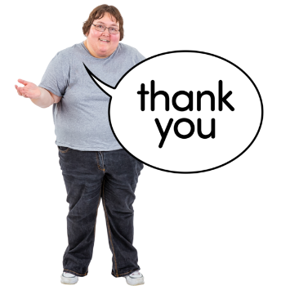 | By completing the survey, you agree we can use your answers.  Thank you for helping us.

Part 1 – Why we are doing this
Pictures | Words
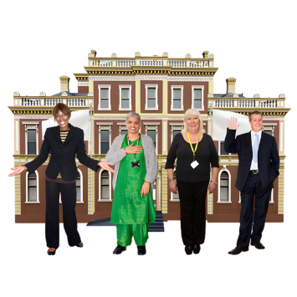   | Cambridgeshire County Council has a lot of money to manage. This money is called a budget.  In 2026-2027, we will have over £1.2 billion to spend on services for the people of Cambridgeshire.
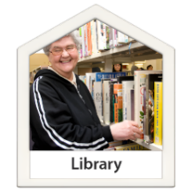    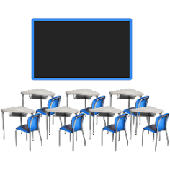 | This money helps pay for services like social care, roads, schools, and libraries.
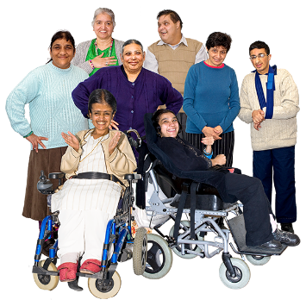 | It also helps protect vulnerable adults and children.  Vulnerable means someone who needs more care and support to stay safe and well.
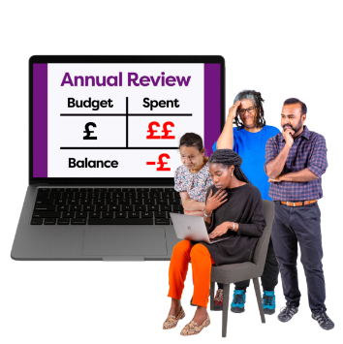   | We have to spend our money carefully.  We cannot spend more than we have, so we must plan our budget well.
Pictures | Words
      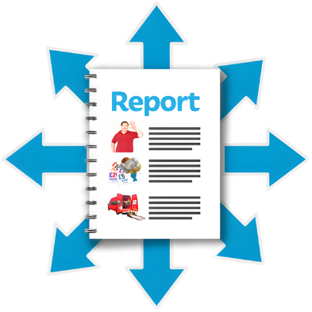 | More people need help from the council, and prices keep going up.  This makes it hard to have enough money for everything.
 | The council needs to find ways to save money or make more money.  We also need to think about new ways to help people.
 | We want to know what you think about our ideas to save money and help people better.
   | We also want to know what you think is most important to spend the money on.
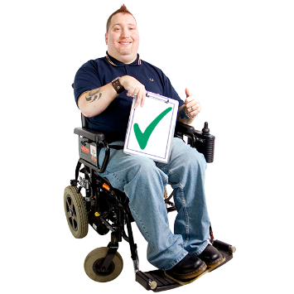 | Your thoughts can help us decide how to use our money well.

Part 2 – What do you think about spending, saving, and investing?
Pictures | Words
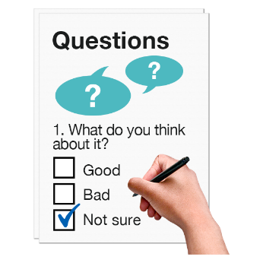  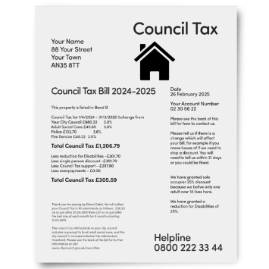 | Many people took part in our first survey about council tax and fees.
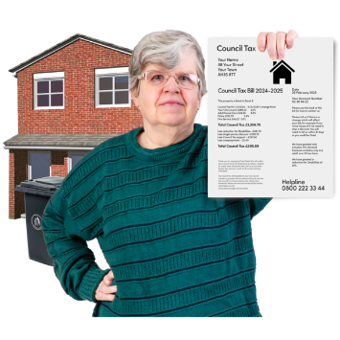   | 53% of people said they were happy for the council to raise council tax.  66% of people said they were happy for the council to raise other fees and charges.
  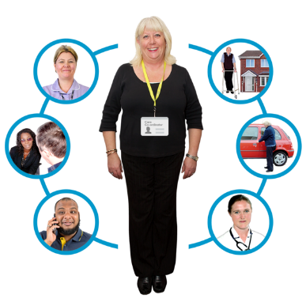 | People were asked where they wanted the extra money to go.
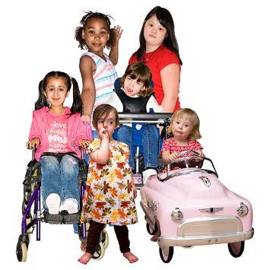 | 65% of people wanted the money to help vulnerable children.
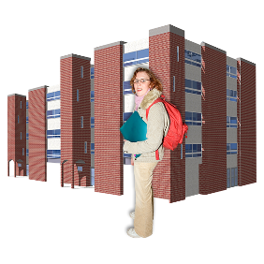  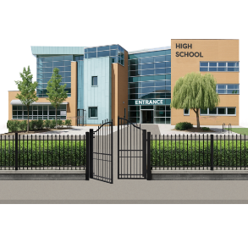 | 56% of people wanted the money to go to education services.
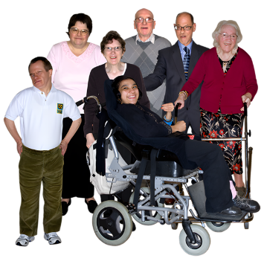 | 53% of people wanted the money to help vulnerable adults.
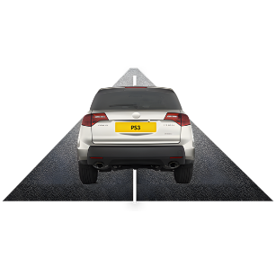    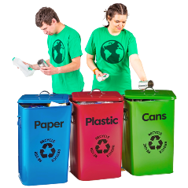 | 49% of people wanted it to go to services that make our area better.  This includes roads, waste disposal, and looking after nature.
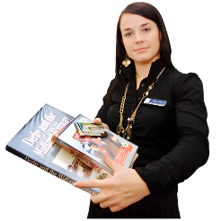  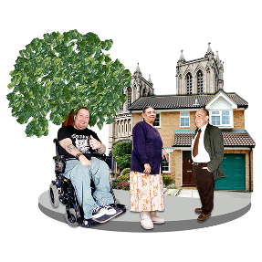 | 26% of people wanted the money to go to community services.  These services include things like libraries and registration services.
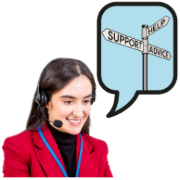  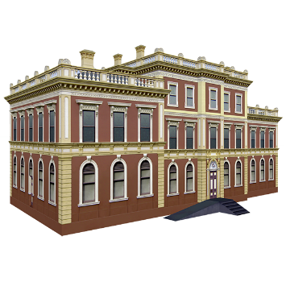 | A small number of people, 4%, wanted the money to go to corporate services.  These services help run the council, like customer services and IT.

Question 1. Services for vulnerable children and education
Pictures | Words
 | In 2026-2027 the council plans to spend £201.6 million on services for children who need help.  This is 16.2% of the council's total money for that year.
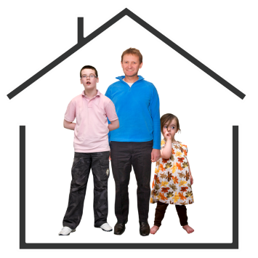 | Some of this money will go to children's social care, fostering, adoption, and special educational needs and disabilities (SEND).
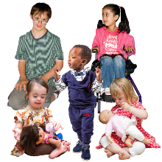 | The council wants to spend £10.4 million to help children who need to be looked after by the council.
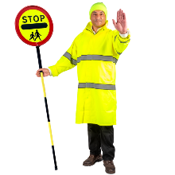  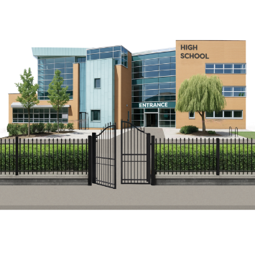 | They also plan to spend £3.8 million to help children get to and from school safely.
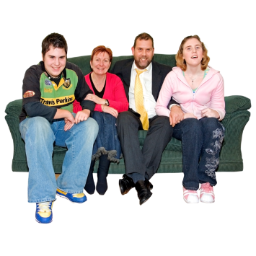 | An extra £406,000 will be used to give families more money directly.  This helps families choose the support they need for children with disabilities.
Question 1 - Do you agree with giving extra money to these services?
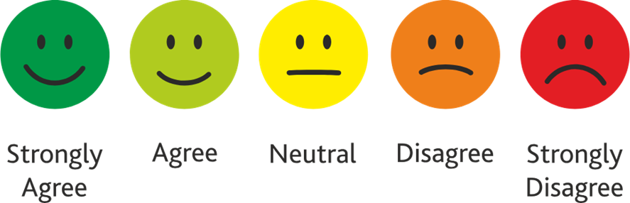

☐ ☐ ☐ ☐ ☐

Question 2. Services for vulnerable children and education
Pictures | Words
 | We help children and young people who are at risk by giving them safe homes.
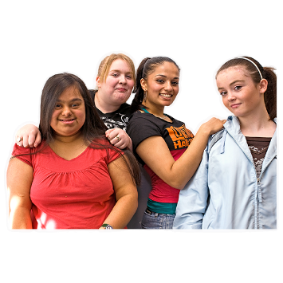 | We check what help children need for school and their health.
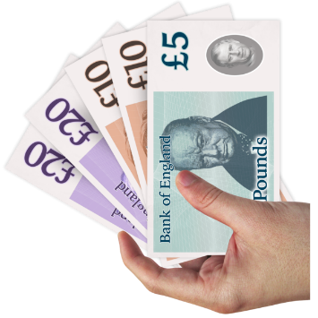 | More children need help getting to school, and this transport costs more money.
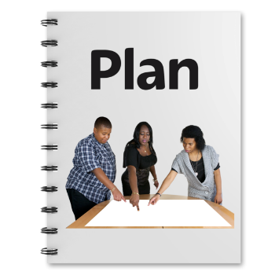 | We have a plan to save money but still help the children and families that need it.
   | We want to have less agency workers because they cost more money.
 | We used to have 38% agency workers, but now we have only 12%.
  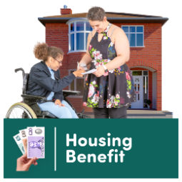 | We will use government money to help where it is needed most.  We will help families get the benefits they should have.
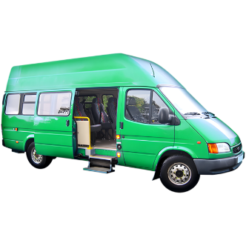  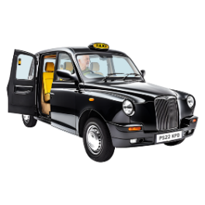  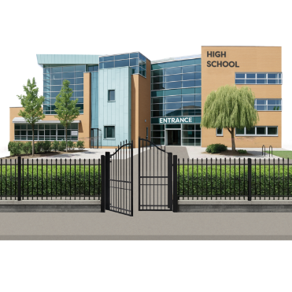 | We will work with others to make school transport cost less.
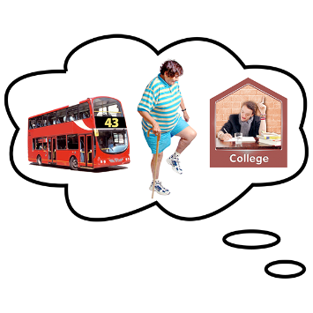 | We will also help young people become more independent so they can use buses or walk or cycle to school.
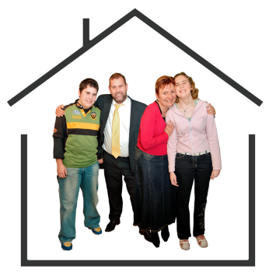 | We will make sure children and young people who need help have safe homes that meet their needs and do not cost too much.
Question 2 - Do you agree with these ideas to save money and spend less?

☐ ☐ ☐ ☐ ☐

Question 3. Services for vulnerable adults and public health
Pictures | Words
   | In 2026-2027, £417.4 million will be spent on services for vulnerable adults and public health.  This is 33.5% of the council's total budget.
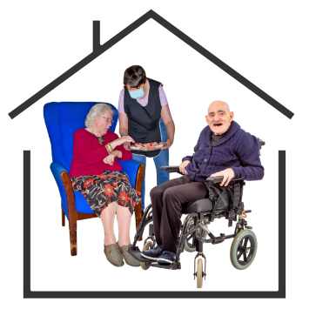 | It will help older people and adults who need care and support.  The money will also help public health services.
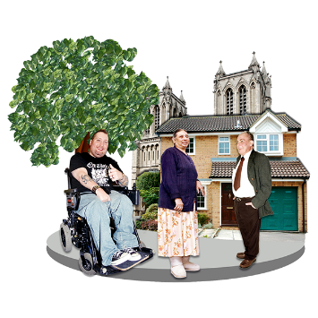 | These services look at things that affect the health of people in the area.  This includes things like where people live and work.
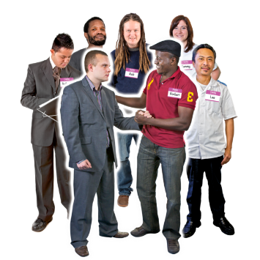 | An extra £14.7 million will go to local care providers.  This will help them with the costs of paying staff and other rising costs.
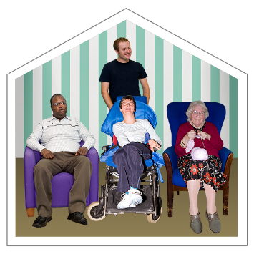 | There will be £1.9 million more to help older people who need care.  This will help people who need care at home or in a care home.
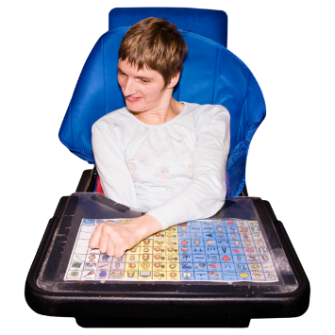 | An extra £4.9 million will be used to help people with a learning disability.  This is because more people need this help.
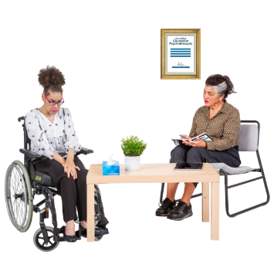 | £2.1 million more will be spent on helping people with mental health needs.  This is for both for working age and older people.
Question 3 - Do you agree with giving extra money to these services?

☐ ☐ ☐ ☐ ☐

Question 4. Services for vulnerable adults and public health
Pictures | Words
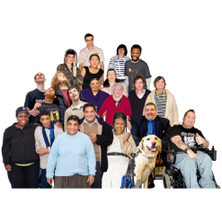  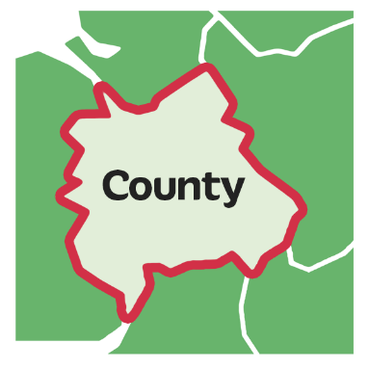 | We are facing more challenges because more people are living in Cambridgeshire now.
 | This means more people need help, especially older people over 65.  This costs more money.
 | The council thinks costs will go up because wages and prices are rising.
     | We have some ideas to save money whilst still helping people.
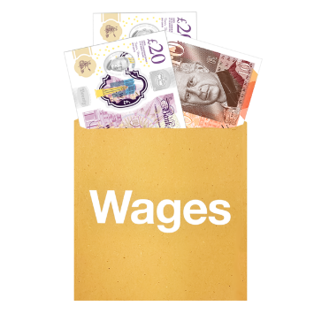 | One idea is to ask care providers to pay their workers the Real Living Wage.  A real living wage means paying people enough money to live on.
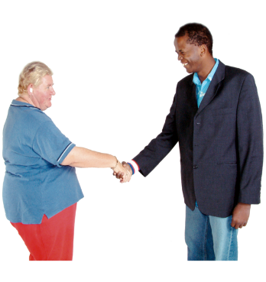  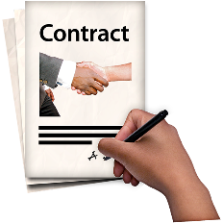 | The council wants to make sure we get good deals with care providers to keep costs low.  This will help us to save money.
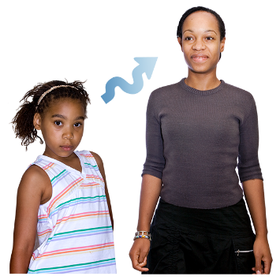 | We also want to help young people move into adult support services easily.  This means them getting the right help as they grow up.
The council plans to help people stay in their own homes longer.

This means they should not need more expensive care too soon.
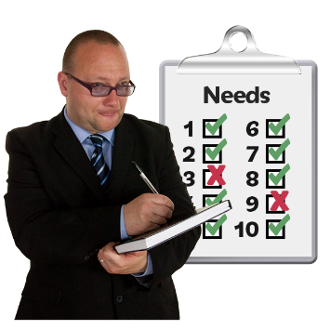 | We will check care packages to make sure people are getting the right help they need.  We also want to make sure the prices for these services are fair.
  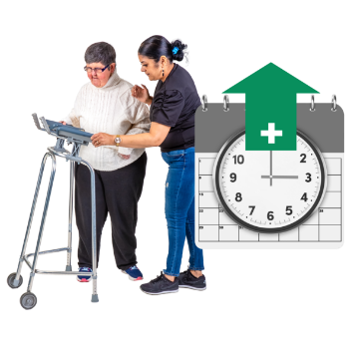 | These ideas are part of our draft budget to help us manage our money and support people well.  We want to make sure everyone gets the help they need.
Question 4 - Do you agree with these ideas to manage our services and save money?

☐ ☐ ☐ ☐ ☐

Question 5. Place, sustainability and community services
Pictures | Words
 | In 2026-27, £136.7 million will be spent on things like roads, nature, and community services.  This is about 10.9% of the council’s total money.
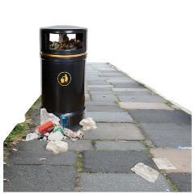   | These services include cleaning up rubbish, stopping floods, looking after nature, fixing roads, and helping people use the internet.
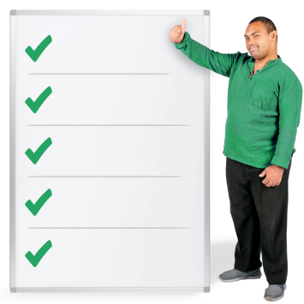 | The council will also spend money on libraries, training, emergency plans, and other important services that help the community.
 | The 2026-2029 budget will also spend money on these important services for the community:
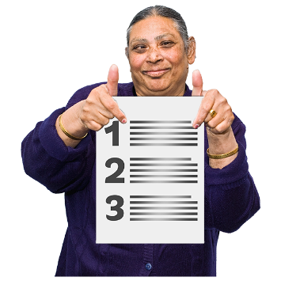 | - £2.4 million will be spent on making roads better. This is part of a £20 million plan.  - £1.6 million will be used to make street lighting better.  - £1.3 million will help with climate change issues, like building solar farms.
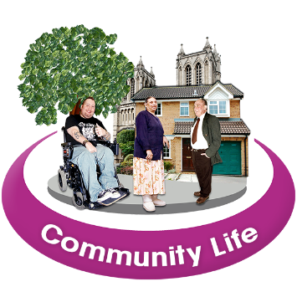 | These plans aim to make the community a better and safer place to live.
Question 5 - Do you agree with the council spending money on these services?

☐ ☐ ☐ ☐ ☐

Question 6. Place, sustainability and community services
Pictures | Words
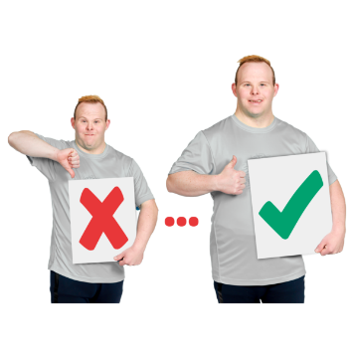 | The council wants to save money and make services better.
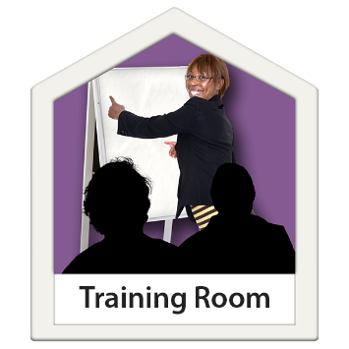 | We will train the people who fix roads so they can do more jobs themselves.  This means we will not need to pay extra people to help.
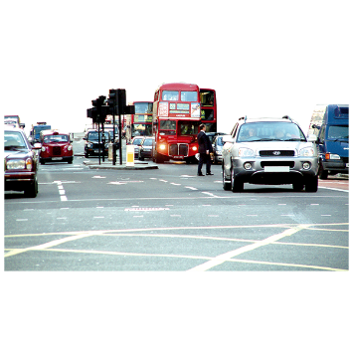 | We want to make more money to keep fixing roads and manage traffic better.
   | We will also spend money on places where people recycle their rubbish.
Question 6 - Do you agree with these ways of saving money and making services better?

☐ ☐ ☐ ☐ ☐
 | Please tell us any ideas you have for making our services better.  Remember do not write any names or personal details.


Part 3 – Questions about you:
Pictures | Words
  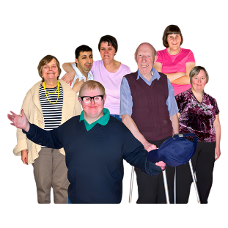 | Are you completing this survey as an individual, an elected individual or on behalf of a business or group?  ☐​ An individual  ☐​ As an elected individual  ☐​ A representative of a business or group
 | If you are answering as an elected individual or for a business or group, please tell us what this is:  ___________________________________________
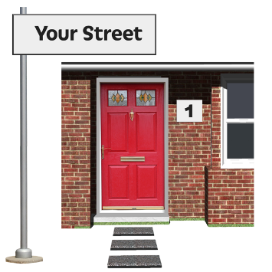  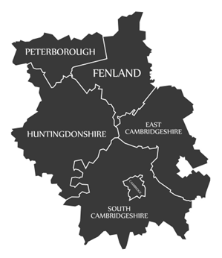 | Please tell us where you live?  ☐ Cambridge City  ☐ East Cambridgeshire  ☐ Fenland  ☐ Huntingdonshire  ☐ South Cambridgeshire  ☐ I do not live in Cambridgeshire  ☐ I do not want to say

